**DAILY ONLINE ACTIVITIES SUMMARY**

|  |  |  |  |  |  |  |  |  |
| --- | --- | --- | --- | --- | --- | --- | --- | --- |
| Date: | 14/06/2020 | | | | | Name: | Jyothi B R | |
| Sem & Sec | IV-A | | | | | USN: | 4AL18CS030 | |
| Online Test Summary | | | | | | | | |
| Subject | | Not conducted. | | | | | | |
| Max. Marks | | ---- | | Score | | | ---- | |
| Certification Course Summary | | | | | | | | |
| Course | Programming Essentials in Python | | | | | | | |
| Certificate Provider | | | Cisco Virtual Academy | | Duration | | | 3hrs |
| Coding Challenges | | | | | | | | |
| |  |  |  | | --- | --- | --- | | |  | | --- | | Problem Statement : Write a C program to remove specific characters in the String. | |  | | | | | | | | | |
| Status:Completed | | | | | | | | |
| Uploaded the report in Github | | | | | Yes | | | |
| If yes Repository name | | | | | https://github.com/alvas-education-foundation/jyothi_b_r | | | |
| Uploaded the report in slack | | | | | Yes | | | |

Online Test Details: (Attach the snapshot and briefly write the report for the same)

Certification Course Details: (Attach the snapshot and briefly write the report for the same)

Coding Challenges Details: (Attach the snapshot and briefly write the report for the same)

**ONLINE TEST DETAILS: NA**

CERTIFICATION COURSE DETAILS:

Programming Essentials in Python :

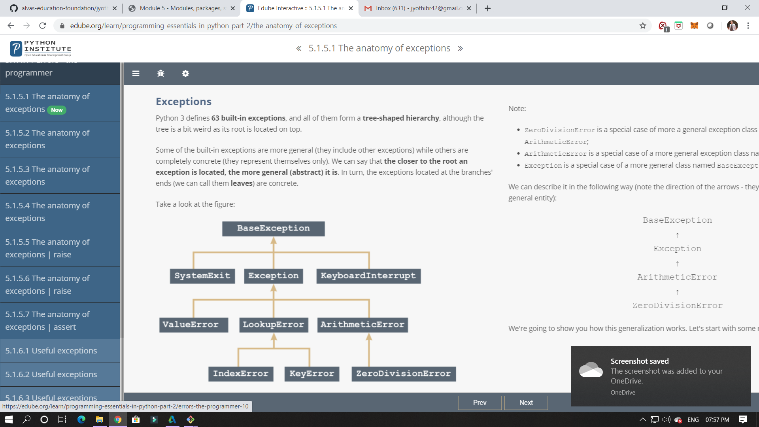

In this module its shows about packages, In this it shows about EXCEPTIONS.

In this module I have studied about packages and how it can be implemented in python.

ONLINE CODING: Write a C program to remove specific characters in the String.

